# Warren Technology details

Note: This document provides information related to technology architecture of warren project. This is a free flowing format document and is not based on any document template.

## Application Architecture

The warren application architecture is based on a multi tier architecture. The diagram given below lists the various tiers in the warren application.

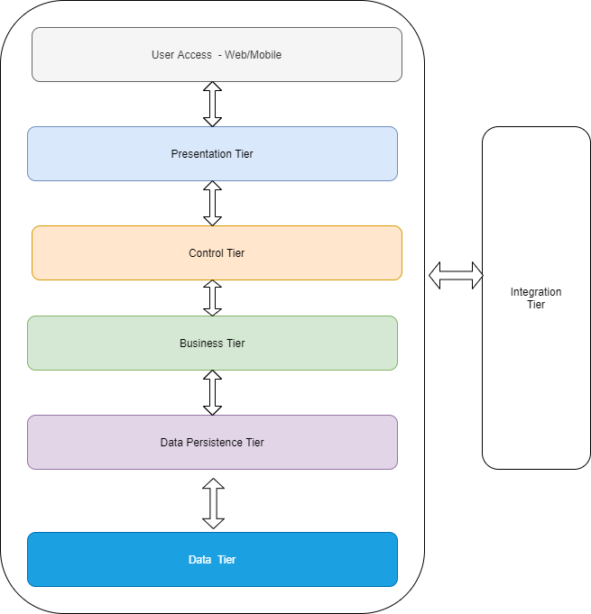

Fig 1: Warren Application Tiers

The warren application can be accessed either through a web browser from desktop or through mobile device.

The presentation tier consist of user interface / user experience features that will allow the warren users to access the system. The details entered by the users is passed to the control tier

The control tier classes will handle the requests that come from presentation tier and invoke the appropriate classes in business tier

The business tier will handle the business operations that are requested from presentation tier and passed by the control tier classes.

The business tier classes will invoke the data persistence classes in the data persistence tier which will access the data tier to fetch or persist data and pass on the details to the business classes

The warren application will interact with interface tier which will fetch details from third party software.

## Technology Architecture

The technology architecture for the warren application is given below

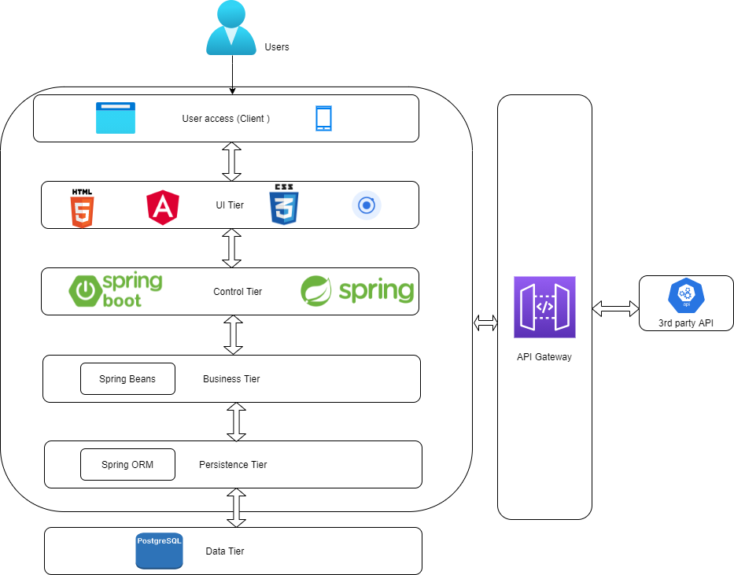Fig 2: Warren Technology Architecture

User Access: Warren users can access the application either through web browser or from mobile. The supported browsers and the mobile access details will be incorporated here as and when they available.

User Interface Tier- The user interface tier would be built using HTML, CSS, Angular JavaScript framework, ionic for mobile, images, icons etc.

Control tier: The control tier would be built using spring framework

Business Tier: The business tier would be built using spring beans and it shall contain the business classes related to warren application

Persistence tier: The persistence tier shall be built using spring orm framework. The spring DAO classes shall contain be used for data persistence

Data Tier: Postgres SQL shall be the database for the warren application. It shall be used to store warren application data.

Integration Tier; Integration tier shall have classes related to accessing the Third party API’s.

## Technology Inventory

The table given below lists some of the tools, technologies, frameworks that shall be used for building the warren application. This is an indicative list and any other tools used during development or deployment may be added later.

|  |  |  |
| --- | --- | --- |
| Sl. No | Description | Tool/ Technology/Framework |
| 1 | UX |  |
| 2 | Wireframes |  |
| 3 | UI Screens | HTML5, CSS3, Ionic 3, Angular 9 |
| 4 | Back-end development framework | Spring boot and Spring framework |
| 5 | Development Language | Java |
| 6 | IDE | Eclipse or similar IDE, IDE for mobile development(Vscode) |
| 7 | Code Formatter | Check style |
| 8 | Static source code analyser | PMD |
| 9 | Source code unit testing | Junit |
| 10 | Database | Postgres SQL |
| 11 | Build Tool | Maven 3.6x |
| 12 | Source code repository | GitHub |
| 13 | CI/CD | Jenkins |
| 14 | Application server | Apache Web server |
| 15 | On Prem server for Dev, UAT, Testing | AWS |

## Acronyms and description

|  |  |  |
| --- | --- | --- |
| Sl. No | Acronym | Description |
| 1. | GUI/UI | Graphical User Interface/User Interface |
| 2. | HTML | Hyper Text Markup Language |
| 3. | CSS | Cascading Style Sheer |
| 4. | API | Application Programming Interface |
| 5 | ORM | Object Relational Mapping |
| 6 | DAO | Data Access Object |
| 7 | UX | User Experience |
| 8 | IDE | Integrated Development Environment |
| 9 | PMD | Programming Mistake Detector |
| 10 | SQL | Structured Query |
| 11 | CI | Continuous Integration |
| 12 | CD | Continuous Delivery |